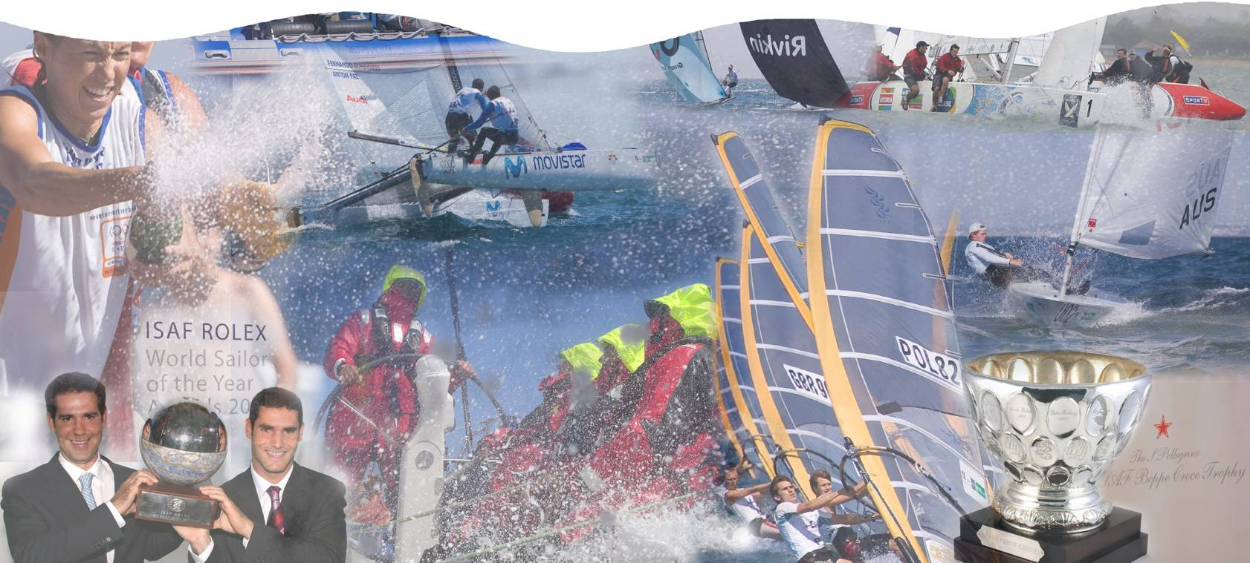

International Sailing Federation

XML Regatta Report Format (XRR)

V1.3.1

**Table of Contents**

Introduction 1

Purpose 1

Overview 1

Specification 2

Enumerations (basic) 2

Enumerations (ISAF extended) 2

Structure 3

# Introduction

## Purpose

This document specifies the structure of the XRR data format and describes the elements that are used to represent yacht racing. Including such data as regatta/regatta-series schedules, nations, entries, biographies, courses, results and weather.

The XRR format is required to allow computer systems to exchange sailing related data electronically in a standardised way and to enable up-to-the-minute and accurate reporting of results from central locations.

## Overview

The data format detailed in this document defines a very broad and descriptive view of sailing-related information in order to be useful for many purposes and scenarios. The following definitions of the elements and their relations are provided to ensure consistent inclusion of information across all implementations.

Potential applications for the standard are as follows:

* Ability to send results from a client based results package back to a web-hosted database (rather than just sending a flat HTML page)
* Digital availability of regatta and event schedules globally and between organisations on a national basis
* Correlation of centrally hosted information against individual client based applications for regatta management
* Historical availability of regatta, event and individual race results to include course set-ups, mark roundings, weather information and official documents
* Download (and upload) service for sailor biographical information

# Specification

## Enumerations (basic)

|  |  |
| --- | --- |
| Name | **CrewPosition** |
| Description | The position applied to a crew member on board a vessel |
| Members | |  | | --- | | S: Skipper, the person in control over the vessel | | C: Crew, not the person in control over the vessel | |

|  |  |
| --- | --- |
| Name | **EventType** |
| Description | Switch for specifying the purpose of an Event element |
| Members | |  | | --- | | Regatta: Information on an individual regatta | | RegattaSeries: Information on a series of linked regattas | |

|  |  |
| --- | --- |
| Name | **DivisionType** |
| Description | The race-format used for the races in a Divison |
| Members | |  | | --- | | FleetRace: *(self explanatory)* | | MatchRace: *(self explanatory)* | | TeamRace: *(self explanatory)* | |

|  |  |
| --- | --- |
| Name | **MatchRaceEntry** |
| Description | Used to specify the starting position of a boat in a match race |
| Members | |  | | --- | | Port: *To port* | | Starboard: *To starboard* | |

|  |  |
| --- | --- |
| Name | **PersonGender** |
| Description | Gender specifier for an individual Person |
| Members | |  | | --- | | Male: *(self explanatory)* | | Female: *(self explanatory)* | |

|  |  |
| --- | --- |
| Name | **EventGender** |
| Description | The gender required for the format of an Event or present on a vessel at an Event |
| Members | |  | | --- | | Men: *(self explanatory)* | | Women: *(self explanatory)* | | Open: *Any combination onboard a boat is acceptable* | | Mixed: *A boat must have a combination of both genders on-board* | |

## Enumerations (ISAF extended)

|  |  |
| --- | --- |
| Name | **IFClassCode** |
| Description | An abbreviated name for each class of boat |

|  |  |
| --- | --- |
| Name | **IFNationCode** |
| Description | 3-letter nation codes as defined by the International Olympic Committee |

|  |  |
| --- | --- |
| Name | **IFBoatStatus** |
| Description | Also known as “Scoring Abbreviations”, these are for specifying circumstances and rulings applied to the involvement of a boat in a race |

|  |  |
| --- | --- |
| Name | **IFCfcnGroup** |
| Description | A classification grouping that may be associated with an ISAF member biography/profile |

|  |  |
| --- | --- |
| Name | **IFCfcnStatus** |
| Description | Textual hint type relating to the existence and validity of an individuals classification |

|  |  |
| --- | --- |
| Name | **IFRaceStatus** |
| Description | Denotes the position of progression of a race as described |

## Structure

The following diagram shows the different entities that make up an XRR document with their relations and the fields used to identify them:

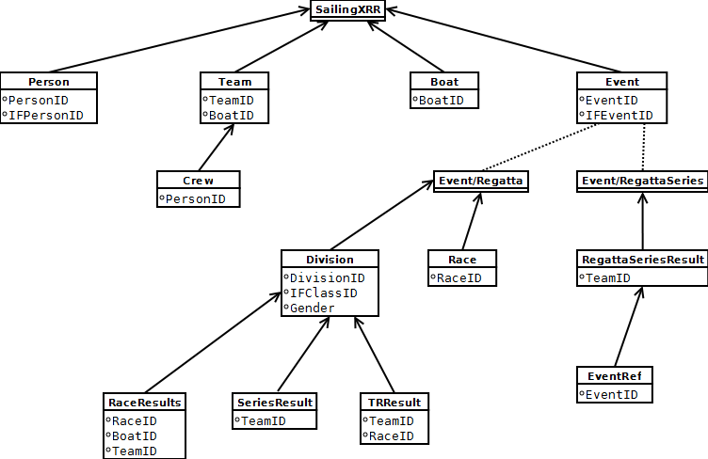

**Element Specifications**

|  |  |
| --- | --- |
| Element Name | **SailingXRR** |
| Element Type | RegattaResults |
| Description | Used as the root element of an XRR document |
| Attributes | |  | | --- | | Date [date]: The date on which the document was generated | | Time [time]: The time at which the document was generated | | Type [string]: n/a (not currently used for anything – populate with dummy information) | | Version [string]: The version of the XRR schema to validate the document content against | |
| Child Elements | Person, Team, Boat, Event |

|  |  |
| --- | --- |
| Element Name | **Person** |
| Element Type | Person |
| Description | Required to represent biography information for an individual included in the document |
| Attributes | |  | | --- | | PersonID [string]: The unique ID of the Person entity/record as recorded in the system on which the document is generated | | IFPersonID [string]: The unique ID used to identify the person according to the International Sailing Federation (ISAF) | | FamilyName [string]: (surname) As recorded in the system on which the document is generated | | GivenName [string]: The name the person is most commonly known by as recorded in the system on which the document is generated | | NOC [IFNationCode]: The code that identifies the nationality of the person as recognised by the International Olympic Committee | | Gender [PersonGender]: The gender of the person in question as recorded in the system on which the document was generated | | ClassificationGroup [IFCfcnGroup]: A classification grouping granted to the Person by ISAF | | ClassificationStatus [IFCfcnStatus]: A status string denoting the presence and validity of the person’s classification | | ClassificationExpiry [date]: The date from which the latest granted classification for the person is no longer valid | |
| Child Elements | n/a |

|  |  |
| --- | --- |
| Element Name | **Boat** |
| Element Type | Boat |
| Description | An entity representing a boat included in the document |
| Attributes | |  | | --- | | BoatID [string]: The unique ID for the boat information as recorded in the system on which the document is generated | | BoatName [string]: A name for the boat as recorded in the system on which the document is generated | | SailNumber [string]: A number for the Boat’s sail as recorded in the system on which the document is generated | |
| Child Elements | n/a |

|  |  |
| --- | --- |
| Element Name | **Team** |
| Element Type | Team |
| Description | An element representing a group of crew members that is applied to a Boat element, if the Team element is referenced elsewhere in the document then this element must be present.  It is the entity used to associate Person elements with Boat elements. |
| Attributes | |  | | --- | | TeamID [string]: A unique ID for the Team as recorded in the system on which the document is generated | | BoatID [string]: Iternal reference to a Boat element included in the current document | | NOC [IFNationCode]: The code that identifies the nationality of the Team as recognised by the International Olympic Committee | | TeamName [string]: The name given to the team as recorded in the system on which the document is generated | | Gender [EventGender]: Used to identify the presence of a single or set of genders for the Team | |
| Child Elements | Crew |

|  |  |
| --- | --- |
| Element Name | **Crew** |
| Element Type | Crew |
| Description | An element that links a Person to a Boat by way of a Team |
| Attributes | |  | | --- | | PersonID [string]: The unique ID used for an internal reference to a Person element | | Position [CrewPosition]: The position the Person is assigned on the Boat on which the Team compete | |
| Child Elements | n/a |

|  |  |
| --- | --- |
| Element Name | **Event** |
| Element Type | Event |
| Description | An element that can be used to represent an individual regatta or a series of regattas (such as the World Cup) |
| Attributes | |  | | --- | | EventID [string]: The unique ID for the event as recorded in the system on which the document is generated | | IFEventID [string]: The unique identifier used by ISAF to recognise the Regatta or RegattaSeries | | Type [EventType]: Denotes the element content | | Title [string]: The name of the event as recorded in the system on which the document is generated | |
| Child Elements | (Race, Division) OR (RegattaSeriesResult) |

**Event-Type: Regatta**

|  |  |
| --- | --- |
| Element Name | **Race** |
| Element Type | Race |
| Description | Element representing a Race included in a particular Division |
| Attributes | |  | | --- | | RaceID [string]: Unique ID for the race as recorded in the system on which the document is generated | | RaceNumber [integer]: The number/order in which the race appears as part of a Division | | RaceName [string]: A name to apply to the Race (if one is present) as recorded in the system on which the document is generated | | RaceStartDate [date]: The date on which the race takes place | | RaceStartTime [time]: The time at which the Race takes place | | RaceStatus [IFRaceStatus]: The running state of the Race | | Stage [string]: A stage name associated with the race (e.g. lead-up, final) | | Flight [string]: A flight name associated with the race (if present) | | Match [string]: A match name associated with the race (if present) | |
| Child Elements | n/a |

|  |  |
| --- | --- |
| Element Name | **Division** |
| Element Type | Division |
| Description | Element representing a set of races identified by the combination of it’s class, gender and whether or not it is for disabled people’s involvement |
| Attributes | |  | | --- | | Type [DivisionType]: One of the DivisionTypes enumeration | | DivisionID [string]: A unique key used to identify the Division within a regatta as recorded in the system on which the document is generated | | IFDivisionID [string]: A unique ID used by ISAF to identify the division (if known) | | Title [string]: A title string for the set of races | | IFClassID [IFClassCode]: The code used by ISAF to identify the class | | Gender [EventGender]: The gender assigned to the set of races | |
| Child Elements | RaceResults, SeriesResults, TRResults |

|  |  |
| --- | --- |
| Element Name | **RaceResult** |
| Element Type | RaceResult |
| Description | Details of the finishing position, points and status for a Team (& Boat) in a Race |
| Attributes | |  | | --- | | RaceID [string]: Internal reference to a unique Race element | | TeamID [string]: Internal reference to a unique Team element | | BoatID [string]: Internal reference to a unique Boat element | | RacePoints[float]: Points allocated to the Boat/Team at the end of the Race | | RaceRank [int]: Final position allocated to the Boat/Team at the end of the Race | | Discard [bool]: Whether this result has been discarded from the overall result | | ScoreCode [IFBoatStatus]: A ruling that has been applied to the Boat/Team | | Entry [MatchRaceEntry]: The starting position of the boat in the case of a match-race | |
| Child Elements | n/a |

|  |  |
| --- | --- |
| Element Name | SeriesResult |
| Element Type | SeriesResult |
| Description | Overall score for a Boat/Team in a particular Division |
| Attributes | |  | | --- | | TeamID [string]: Internal reference to an individual Team element | | TotalPoints [int]: Overall score for a Team/Boat accumulated for all Races in the Division before applying any overall calculations | | NetPoints [int]: Overall score for a Team/Boat accumulated for all Races in the Division with overall calculations applied | | Tied [bool]: Specifies that the overall result is a tie with another Team/Boat | | Rank [int]: Overall finishing position applied to the Team/Boat for the Division | |
| Child Elements | n/a |

|  |  |
| --- | --- |
| Element Name | **TRResult** |
| Element Type | TRResult |
| Description |  |
| Attributes | |  | | --- | |  | |  | |
| Child Elements |  |

**Event-Type: RegattaSeries**

|  |  |
| --- | --- |
| Element Name | **RegattaSeriesResult** |
| Element Type | RegattaSeriesResult |
| Description | Used for reporting the overall scores for teams across a number of linked regattas |
| Attributes | |  | | --- | | TeamID [string]: Unique internal reference to a Team element as recorded in the system on which the document is generated | | TotalPoints [string]: Overall points for the Team – sum of final results from all regattas | | Rank [string]: Overall finishing position for the Team | |
| Child Elements | EventID |

|  |  |
| --- | --- |
| Element Name | **EventID** |
| Element Type | EventRef |
| Description | A unique ID for a regatta included in the series as recorded in the system on which the document is generated |
| Attributes | |  | | --- | | Value [string]: The unique ID | |
| Child Elements | n/a |

|  |  |
| --- | --- |
| Element Name |  |
| Element Type |  |
| Description |  |
| Attributes | |  | | --- | |  | |  | |
| Child Elements |  |